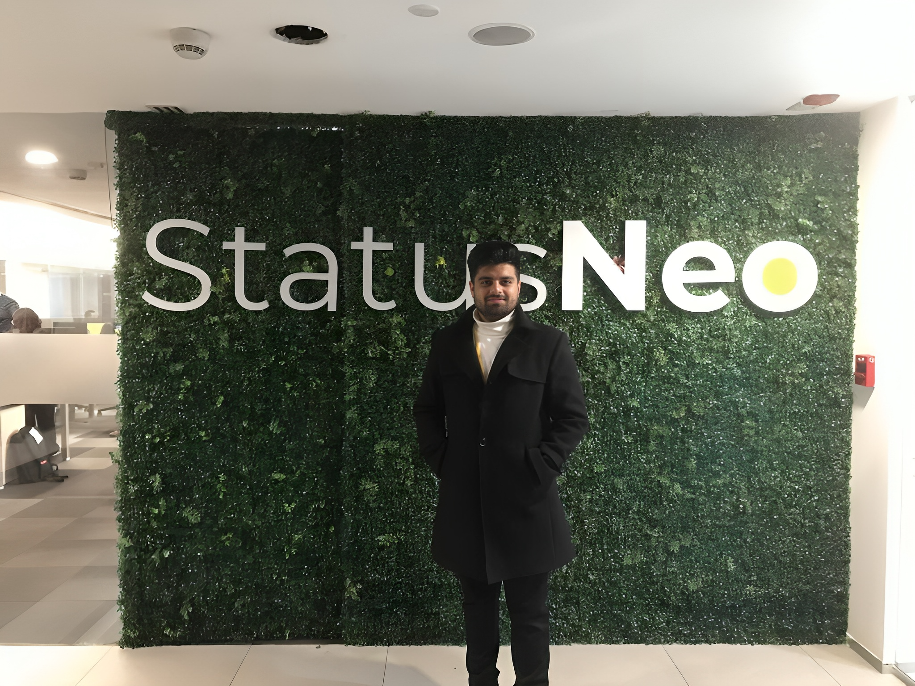

* Name: Manil Munjal
* University: University of Petroleum and Energy Studies
* Batch: CSE with CCVT (2020 - 2024)
* Hometown: Fatehabad, Haryana
* Background: Cloud Computing, Cyber security and forensics
* Goals: Propel businesses into the digital age, transforming creative ideas into real-world solutions in the dynamic realm of technology.
* Motivation: Ignite innovation in the digital realm.
* GitHub: <https://github.com/manilmunjal>
* LinkedIn: <https://www.linkedin.com/in/manil-munjal/>